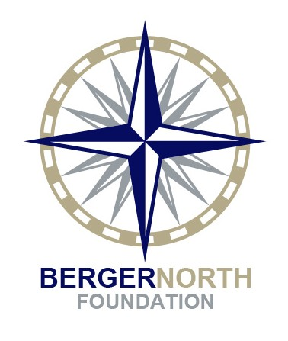Berger North Foundation
1624 Highway 395 STE #3
Minden, NV 89423
Tel 775.782.3013
Fax 775.782.3014
www.bergernorthfoundation.org ingrid@bergernorthfoundation.org

MULTI-YEAR PROJECT BUDGET

Applicant Organization: Grant Project Title:

REVENUES
Year One  Total Project Berger North Funding Funding |  |  |  | Year Two (if applicable)  Total Project Berger North Funding Funding |  |  |  | Year Three (if applicable) Total Project Berger North Funding Funding
$ | - | $ | - | $ | - | $ | - | $ | - | $ | -
)
S $ - |  | $ | - | $ | - | $ | - | $ | - | $ | -

Grants/Contracts
Government Foundations Corporations UnitedWay Individual Donors
Other

Earned Revenue
Events Publications & Prods
Fees Membership
In Kind Other (specify) TOTAL REVENUES

EXPENSES

Salaries

Payroll Taxes Fringe Benefits Consultants
Travel Equipment Supplies Printing Telephone Postage
Rent & Utilities Maintenance Technology Evaluation
In-kind Other (specify
TOTAL EXPENDITURE

