Berger North Foundation
1624 Highway 395 STE #3
Minden, NV 89423
Tel 775.782.3013
Fax 775.782.3014
Cell 775.315.0274
Bergernorthfoundation.org Ingrid@bergernorthfoundation.org

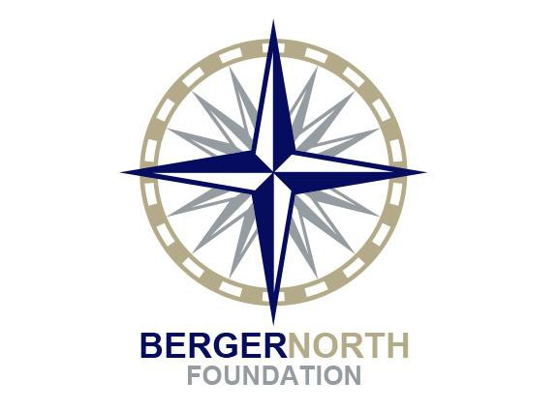

PROJECT BUDGET

Applicant Organization: Grant Project Title:

REVENUES
Grants/Contracts
Government Foundations Corporations UnitedWay Individual Donors
Other

Total Project Funding
Berger North Funding

Earned Revenue
$ -
$ -
Events Publications & Prods
Fees Membership
In Kind Other (specify) TOTAL REVENUES

EXPENSES

Salaries Payroll Taxes
$ -
$ -

Fringe Benefits Consultants
Travel Equipment Supplies Printing Telephone Postage
Rent & Utilities Maintenance Technology Evaluation
In-kind Other (specify)

TOTAL EXPENDITURES

